Overview of Bilingual Education Programs in Ontario

Elementary and Secondary Programs in Ottawa, Ontario
(Differences exist between school boards in Ontario.)

a) Ottawa-Carleton District School Board
Elementary Programs (Core French; EFI; MFI)
- Core French (=English Program)
Core French is an integral part of the English Program. French is taught for the equivalent of 100 minutes per week in junior and senior kindergarten and 200 minutes per week from grades 1 to 8 inclusive.
- Early French Immersion (EFI)
SK 50% French
Grade 1 100 % French
Grade 2,3 80% French
Grade 4-6 60% French
Grade 7, 8 50% French
- Middle French Immersion (MFI)
Grade 4-6 66% French
Grade 7,8 50% French

Secondary Programs (Core French, Extended French, French Immersion)
(copied from http://www.ocdsb.ca/programs/sec/fsl/Pages/FSL-Programs.aspx)

- Core French (=English Program)
The aim of the Core French Program is to provide students with fundamental communication skills in French and an understanding of the nature of the language and its culture. Core French offers students the chance to develop a usable command of the French language that can be expanded through further study or through contact with French-speaking people. By the end of the four-year program students will be able to participate in a straightforward conversation in French; will be able to read, with the help of a dictionary, books, magazines and newspapers in French; and will be able to understand the general meaning of radio and television news and other programs.

- Extended French
The aim of the Extended French Program is to develop students’ French language knowledge and skills and to provide them with an understanding and appreciation of francophone culture in Canada and around the world. By the end of the four-year program students will be able to converse freely on familiar topics; will be able to read, with the occasional help of a dictionary, books, magazines and newspapers in French; and will be able to function in a French-speaking community. Schools grant a certificate in Extended French if the student has successfully completed the sequence of four courses in Extended French and a minimum of three courses in other subjects taught in French.

- French Immersion
The aim of the French Immersion Program is to develop and refine students’ ability to communicate in French as well as to expand their knowledge of the language through the study of francophone literature and nonfiction texts. By the end of the four-year program students will participate with confidence in daily conversations, oral interactions and group discussions. They will be able to take courses at the college or university level in which French is the language of instruction, and will be able to accept employment in which French is the working language. Schools grant a certificate in French Immersion if the student has successfully completed the sequence of four courses in French Immersion and a minimum of six courses in other subjects taught in French.

- OCDSB Grade 12 French Proficiency Test
(copied from http://www.ocdsb.ca/programs/sec/fsl/Pages/OCDSB-Grade-12-French-Proficiency-Test.aspx)

What is the DELF?
The Diplôme d’études en langue française (DELF) is an internationally recognized test of French proficiency. It is based on the Common European Framework of Reference (CEFR), which defines language proficiency along six global levels: A1, A2, B1, B2, C1 and C2. At each level, proficiency is measured across four competencies: listening, speaking, reading, and writing. The French Ministry of National Education awards successful candidates a diploma.

History of DELF testing in the OCDSB
In 2010, the OCDSB became lead board for a province-wide research project examining the DELF as a Grade 12 French proficiency test. After four testing phases, student interest continue to grow and 98% of participating students have been successful. We are pleased to continue to offer the DELF to OCDSB students who are currently enrolled in a grade 12 FSL course and who have not previously participated.
What is required?
The OCDSB offers students a choice of 3 test levels: A2, B1, or B2. Your choice should be made with help from your FSL teacher. The DELF has 2 components: a written exam and an oral interview. Where possible, the written exam will take place at your school, while the oral interview will be scheduled at one of two testing sites across the district. The written exam starts at 12:00 Noon on each testing date. Oral interviews take place within 3 weeks of completion of the written exam. The OCDSB offers students a choice of 3 test levels: A2, B1, or B2. Your choice should be made with help from your FSL teacher.
Additional information about the DELF can be found at: www.ciep.fr/delf-scolaire/exemples-de-sujets-delf-scolaire.php or http://delf-dalf.ambafrance-ca.org/se-formerse-preparer/exemples-de-sujets-delf-dalf
Test Level | Date of Written
B2 (most difficult) | April 13
B1 | April 14
A2 (least difficult) | April 15

b) Ottawa Catholic School Board
(http://www.ocsb.ca/programs/general-programs/french-at-ocsb/fsl-subjects)

- Extended French; Core French
Grade 1-6 25% French
Grade 7, 8 1 of 8 subjects taught in French

- French Immersion
Grade 1-6 50% French
Grade 7, 8 5 of 8 subjects taught in French

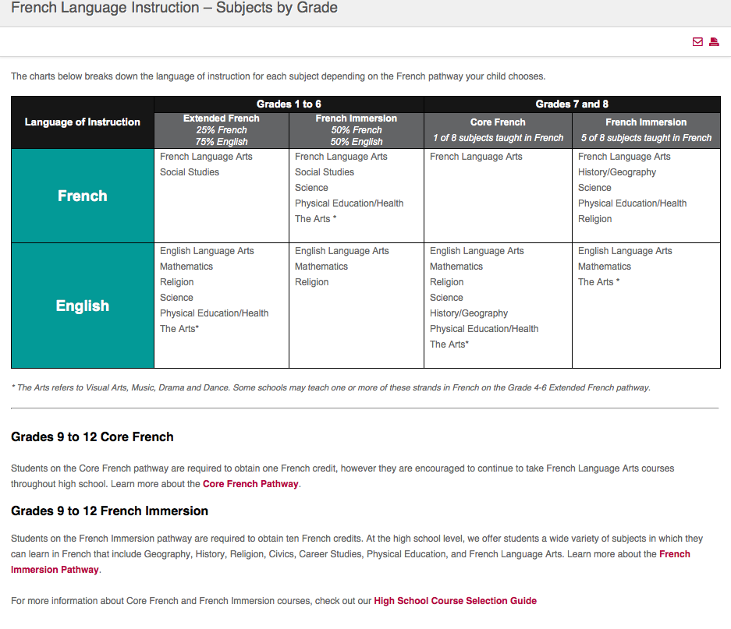

2. Post-secondary education bilingual/French programs in Ontario
Ontario has:
- two publicly funded French-language colleges
Collège Boréal (7 campuses) Main campus: Sudbury
La Cité collégiale, Ottawa
- ten French-language and bilingual schools offering university programs
Université de Hearst, Hearst
Laurentian University, Sudbury
University of Ottawa, Ottawa
Saint Paul University, Ottawa
Sudbury University, Sudbury
Glendon Campus, York University, Toronto
Alfred Campus, University of Guelph, Alfred
Dominican University College, Ottawa
Ontario Institute for Studies in Education University of Toronto
Royal Military College, Kingston

